Executive Summary

Goal & Scope
Week 2 delivered a secure, role-based foundation for the Course Enrollment System, focused on user authentication, course creation, student enrollment, and basic admin oversight, using only core academic entities.
Key Features:
- Role-based login (Student, Lecturer, Admin) with Spring Security
- Lecturer course creation with validation (code format, capacity, term)
- Student enrollment with automatic waitlist when course is full
- Responsive Thymeleaf + Tailwind UI with role-aware views
- Admin dashboard showing system metrics

Technologies
Spring Boot, Thymeleaf, Tailwind CSS, MySQL, Flyway, Spring Security, Maven

Team Roles and Contributions
Role | Team Member
Security & Authentication Lead | David
Student Features | Rasy
Lecturer Features | Hour
Admin Features | Seyha
Database, Infrastructure & DevOps Lead | Rith

System Overview
The Course Enrollment & Classroom Scheduling System is a web-based academic management platform designed to streamline course registration, scheduling, and role-based interactions among Students, Lecturers, and Administrators. Built using a classic Spring Boot layered architecture, the system ensures separation of concerns, testability, and maintainability.

Key Characteristics
- User Roles:
  - Student: Browse courses, enroll, view schedule
  - Lecturer: Create courses, assign schedules, record attendance
  - Admin: Manage academic terms, rooms, and system metrics
- Core week 1 & 2 Scope: Authentication, course creation, enrollment, and role-based dashboards
- Data Integrity: Enforced via MySQL constraints and Flyway-managed schema
- Security: Role-based access at URL, method, and UI levels
- UI: Responsive, server-rendered with Thymeleaf + Tailwind CSS

High-Level Architecture
The system follows a clean 5-layer architecture, from user interface down to persistent storage:
- UI Layer: Renders responsive HTML pages using Thymeleaf templates; handles user input and displays feedback.
- Controller Layer: Receives HTTP requests, validates input, and delegates to services; returns view names or redirects.
- Service Layer: Contains core business logic (enrollment rules, validation, waitlist promotion); transactional boundary.
- Repository Layer: Manages data access via JPA; abstracts SQL interactions.
- Database Layer: Persistent storage using MySQL with enforced constraints (unique keys, foreign keys, checks).

Requirements Specification

Functional Requirements (Week 1 & 2)
- User Login: Students, Lecturers, and Admins log in and are sent to their own dashboard.
- Create Course: Lecturers can create courses with code (like GIC25DB), title, capacity, and term.
- Enroll in Course: Students can enroll if the course has space.
- Waitlist: If a course is full, students are automatically added to a waitlist.
- No Duplicates: A student can’t enroll or waitlist in the same course twice.
- Admin View: Admins see total counts of users, courses, and terms.

Non-Functional Requirements
- Secure: Users only see features for their role.
- Reliable: Data rules (like unique course codes and capacity limits) are enforced.
- Maintainable: Database changes use Flyway; code is reviewed before merging.
- User-Friendly: Clear messages (like “Added to waitlist”) appear after actions.

Database Design

Entity-Relationship Diagram (ERD)
The system uses a normalized 12-table relational schema designed to support flexible course offerings, multi-lecturer assignments, waitlists, scheduling, and attendance. The core structure separates reusable definitions (like courses) from term-specific instances (course_offerings).
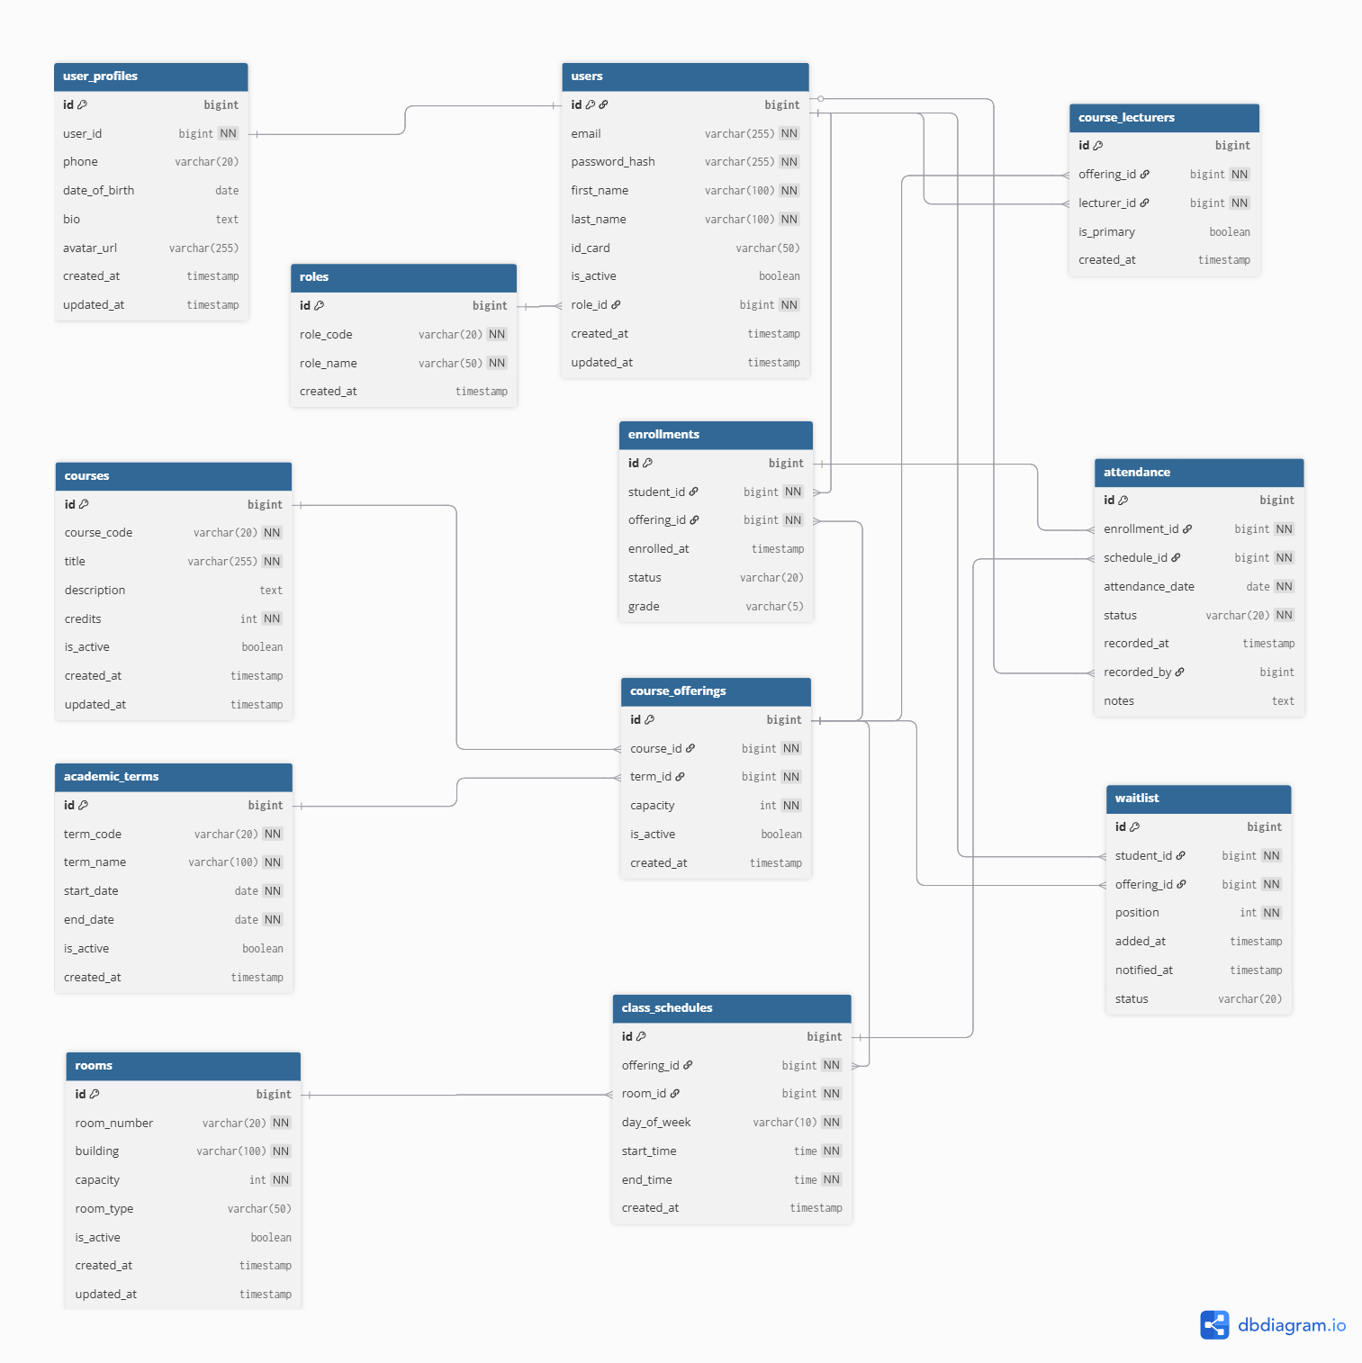

System Architecture & Design

Component Diagram
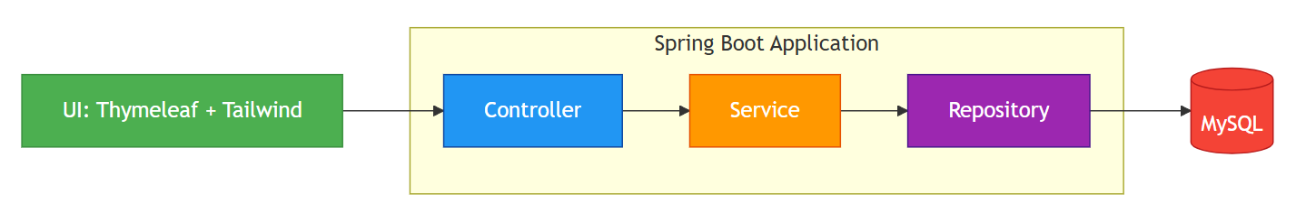

Sequence Diagram: Student Enrollment Flow
This diagram captures the core Sprint 1 workflow: a student enrolling in a course, including capacity check and automatic waitlist fallback.
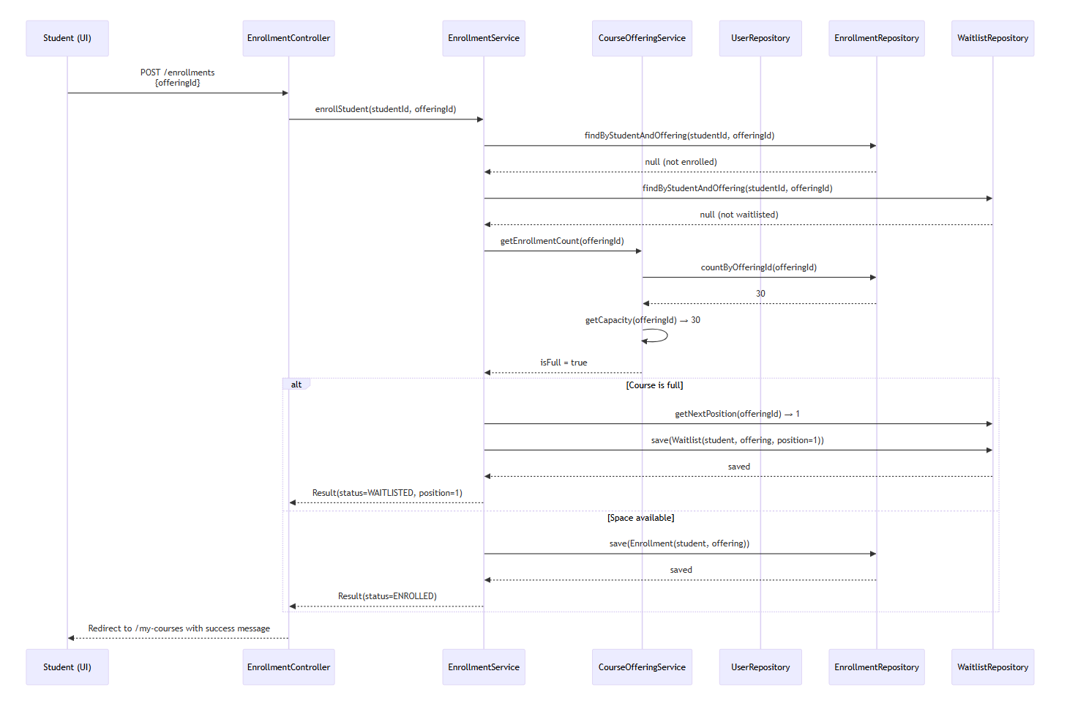 Rules Enforced:
- No duplicate enrollment/waitlist
- Capacity check → auto waitlist
- Atomic save operation

Sequence Diagram: Lecturer Course Creation
This diagram shows how a lecturer creates a course offering in an active academic term, with auto-assignment of lecturer and code validation.
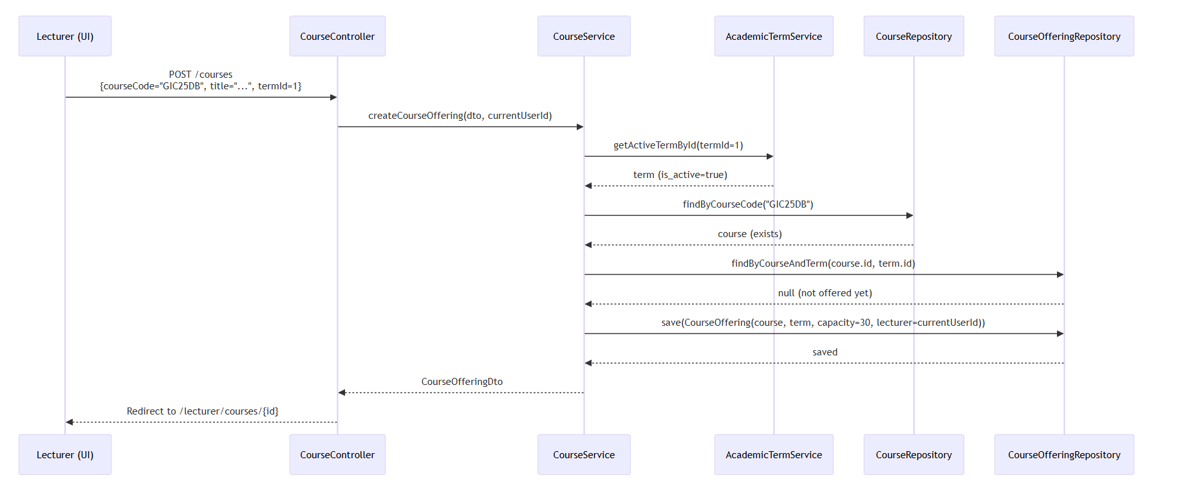

Security Implementation

Authentication Flow
1. User Login
- Users authenticate via email/password at /login.
- Credentials are verified against the users table (email, password_hash).
- On success, a session is created, and the user is redirected based on their role_id (via roles.role_code).
2. Role Mapping
- The CustomUserDetailsService loads user details and maps roles.role_code to Spring Security authorities:
  - STUDENT → ROLE_STUDENT
  - LECTURER → ROLE_LECTURER
  - ADMIN → ROLE_ADMIN
3. Session Management
- Sessions are stateful (stored server-side).
- Logout clears the session and redirects to /login?logout.

Data & Password Security
Aspect | Implementation
Password Storage | BCrypt hashing (BCryptPasswordEncoder)
Sensitive Data | No raw passwords logged; password_hash only in DB
CSRF Protection | Enabled by default in Spring Security (form-based apps)
SQL Injection | Prevented via JPA parameterized queries (no native SQL in Sprint 1)

UI/UX Design
The user interface is built with server-rendered Thymeleaf templates and styled using Tailwind CSS (via CDN). The design follows a component-based approach, promoting reuse and consistency.

Design Principles
- Role-Centric Views: UI adapts to user role—students never see lecturer actions.
- Immediate Feedback: Clear success/error messages after form submissions.
- Minimalist Aesthetic: Focus on content over decoration; consistent spacing and typography.

Key Screens (week 1-2)
🎓 Login Page
- Clean form with email/password fields
- Error display for invalid credentials
- University-branded header
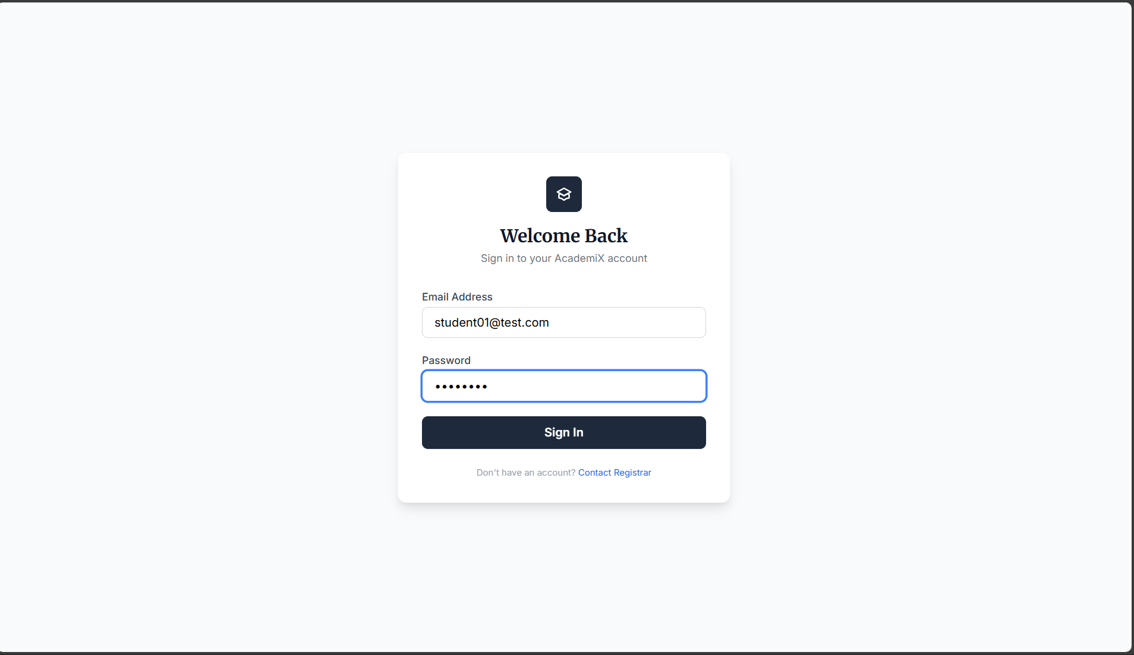
👨‍🏫 Lecturer Dashboard
- “Create Course” button (only visible to lecturers)
- List of My Courses with term and enrollment count
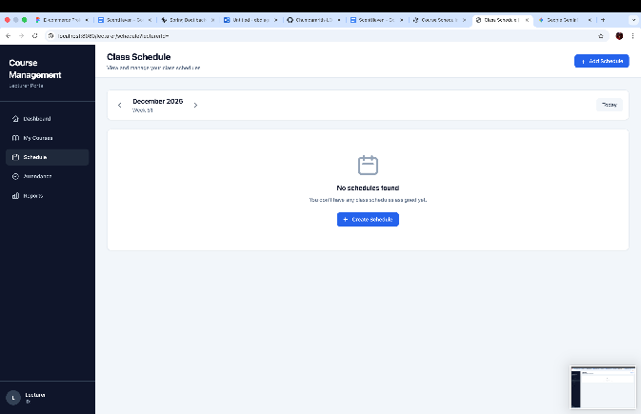
- \Quick links to attendance (week 3)
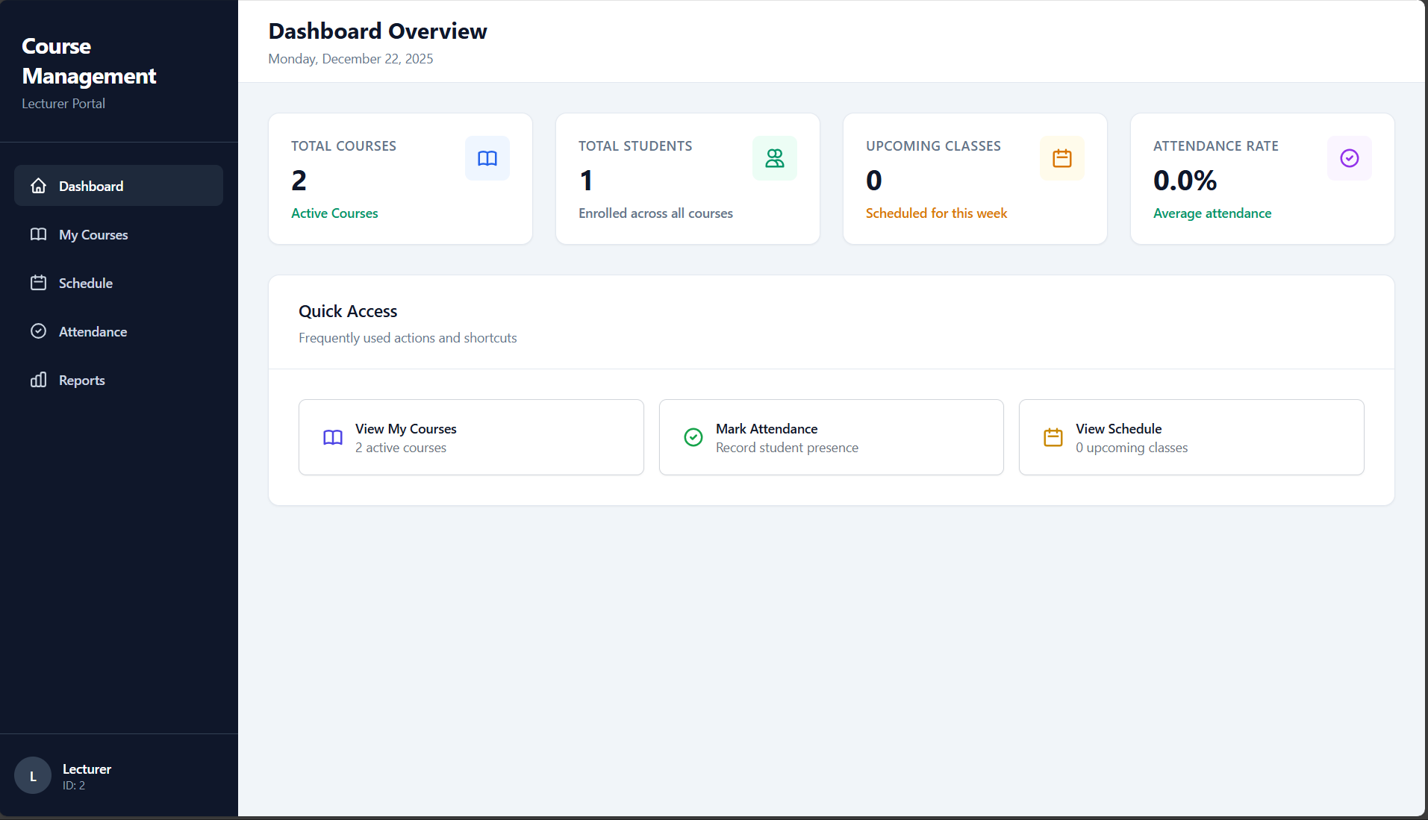
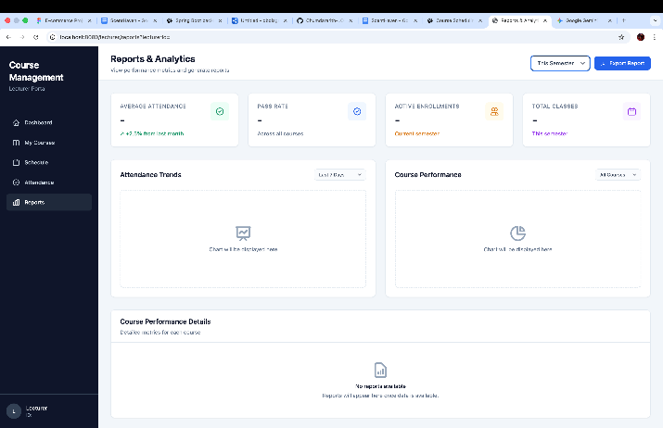
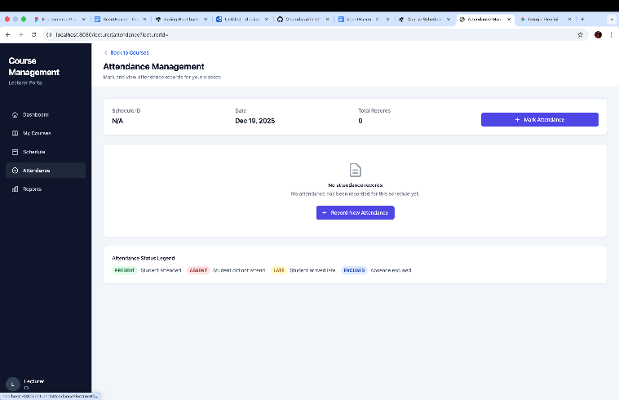

👩‍🎓 Student Dashboard
- Course Catalog: Grid of available courses in active term
- My Courses: List of enrolled courses (status: “Enrolled”)
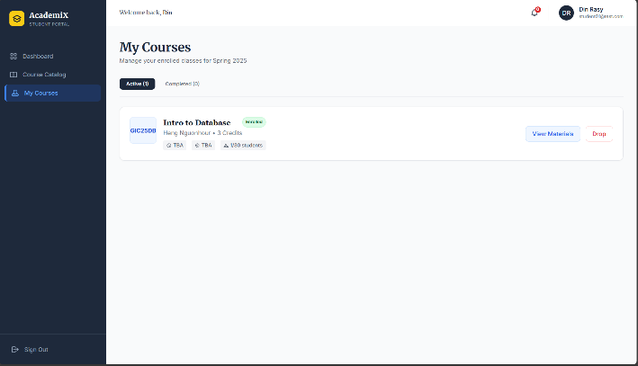
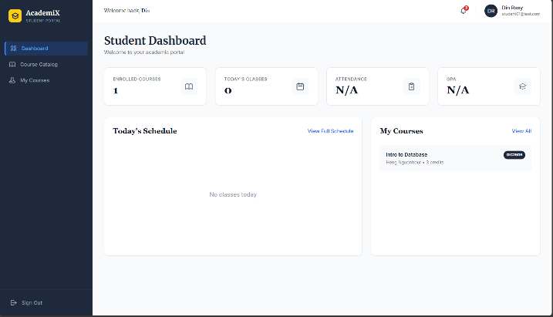
- Empty states: “No courses yet” illustration with CTA
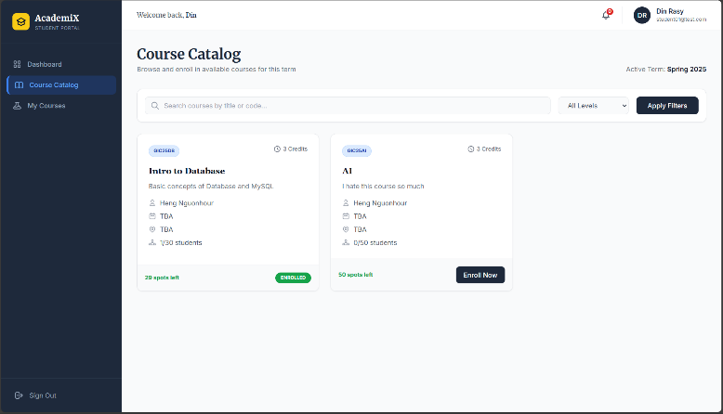
👔 Admin Dashboard
- Metrics cards: Total Students, Lecturers, Courses, Active Terms
- Secure access (403 if non-admin)
- Navigation stubs for future term/room management

Development Process
Our team followed an agile, collaborative workflow over Sprint 1 (8 – 22 December 2025).

Team Structure & Responsibilities
Role | Member | Focus Area
Security & Authentication Lead | David | Spring Security, role-based access, login/logout
Main Entity CRUD Developer | Rasy | users, courses, course_offerings, enrollments, waitlist
Secondary Module CRUD Developer | Hour | rooms, class_schedules, attendance (Sprint 2 prep)
Admin Developer | Seyha | Admin dashboard, role-based UI, system metrics, Thymeleaf layout
Database & DevOps Lead | Rith | MySQL schema, Flyway migrations, seeding, dev setup

Git & Code Review Workflow
We adopted a dual-commit review strategy to ensure quality before merging:

Draft Commit
- Developer implements a logical unit of work (like “build admin dashboard UI”)
- Pushes commit with [REVIEW] draft: ... message
- Notifies team for inspection

Peer Review
- At least one teammate tests the feature and checks code quality
- Feedback is given via Git comments or direct discussion

Official Commit
- After approval, developer amends the draft commit with a conventional message
- Example:
  - Draft: [REVIEW] draft: create admin dashboard with user counts
  - Official: feat(admin): implement admin dashboard with system metrics

Merge to develop
- Only official commits are merged via pull request
- No draft commits remain in the final history
Result: Clean, professional Git history with full team participation.

Branching Strategy
Branch Type | Example | Purpose
main | main | Protected — stable, deployable code
Developer’s Name | Lou-chumdararith | For each user tasks — one per task card
develop | release/sprint-1 | Final integration branch (optional)
- All work done in feature branches
- Merged to develop only after review and approval
- main always passes mvn spring-boot:run with empty DB

Tools & Technologies
Category | Tools
IDE | IntelliJ IDEA, VS Code
Backend | Spring Boot 3.3, Spring Security, Spring Data JPA
Frontend | Thymeleaf, Tailwind CSS (via CDN)
Database | MySQL 8.0, Flyway, HikariCP
Build | Maven
Version Control | Git + GitHub
Diagrams | dbdiagram.io, Mermaid

Appendices

Appendix A: Full ER Diagram (Sprint 1 Schema)
Figure A1: Complete Entity-Relationship Diagram showing all 12 tables and relationships. Generated using dbdiagram.io.
🔗 View/Edit Online: https://dbdiagram.io/d/6898a585dd90d17865441dfa

Appendix B: Sample Flyway Migration (V1__init_schema.sql)
E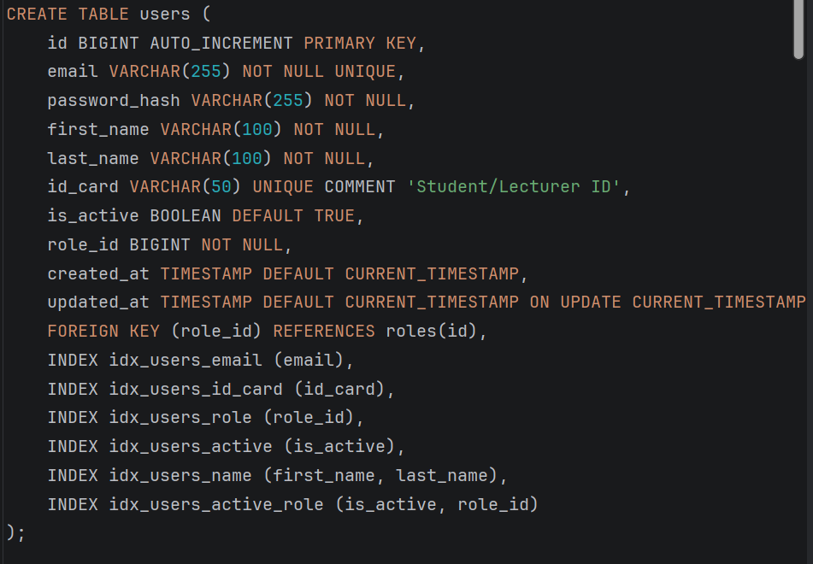

Appendix C: Key API Endpoints (week 1-2)
Method | Endpoint | Description | Role
GET | /login | Login page | Public
POST | /login | Authenticate user | Public
GET | /student/catalog | View available courses | STUDENT
POST | /enrollments | Enroll in course | STUDENT
GET | /lecturer/courses | View my courses | LECTURER
GET | /lecturer/courses/new | Show course creation form | LECTURER
POST | /courses | Create course offering | LECTURER
GET | /admin/dashboard | Admin metrics dashboard | ADMIN

Appendix D: Team Member Contributions (week 1-2)
Member | Key Deliverables
David | Spring Security config, role-based redirects, login/logout, sec:authorize integration
Rasy | Course, Enrollment, Waitlist entities/services, capacity logic, duplicate prevention
Hour | Room, ClassSchedule, Attendance entity design; scheduling conflict rules (Sprint 2 prep)
Seyha | Admin dashboard, Thymeleaf layout, role-aware UI fragments, responsive design
RITH | Full Flyway migrations (V1–V2), MySQL setup, seed data, report documentation

Appendix E: Screenshots

E1: Login Page

E2: Student Course Catalog
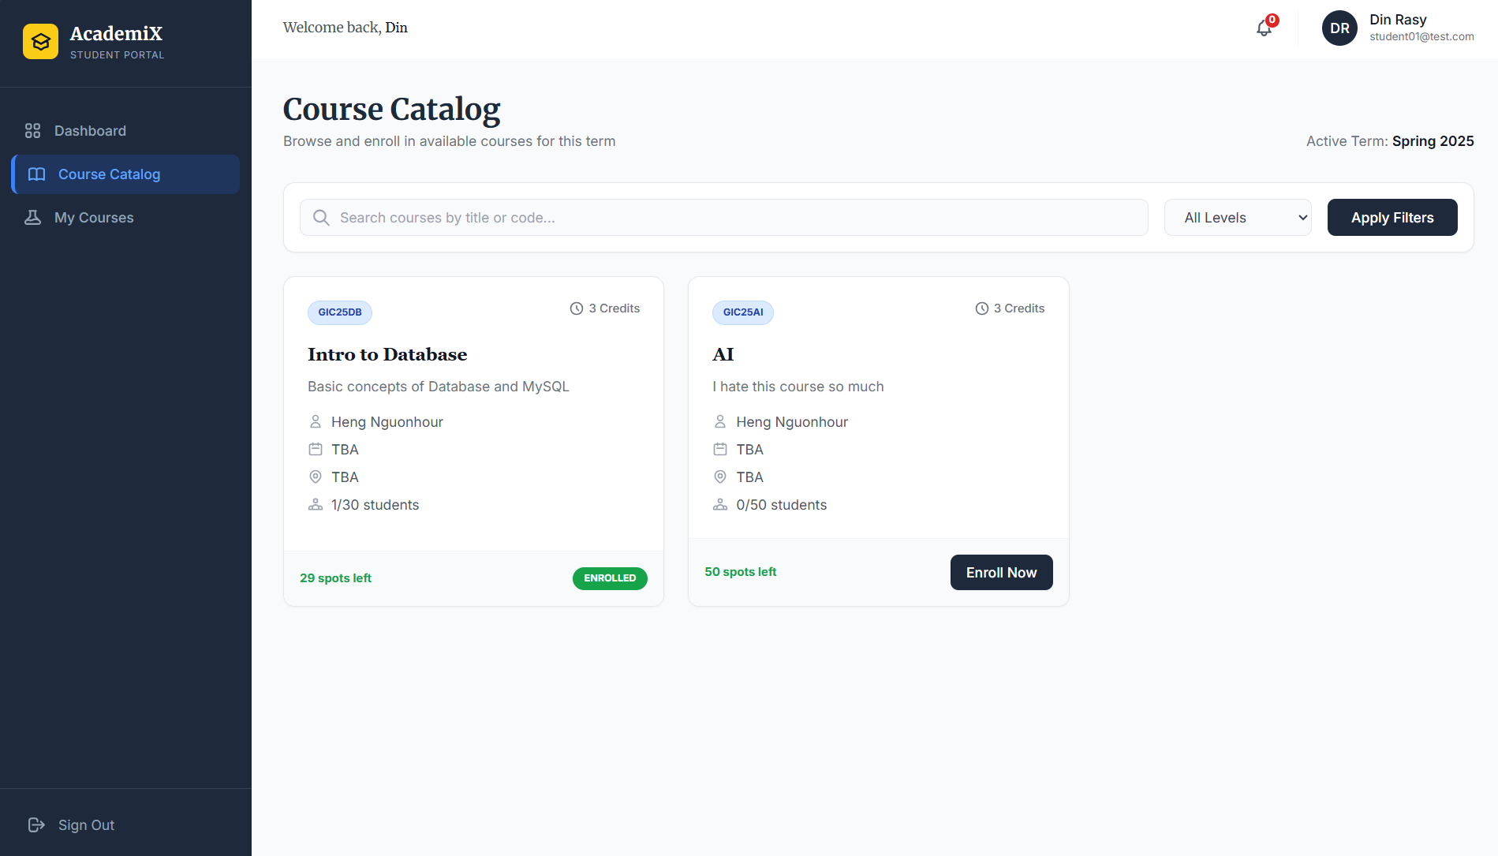

E3: Lecturer Course Creation Form
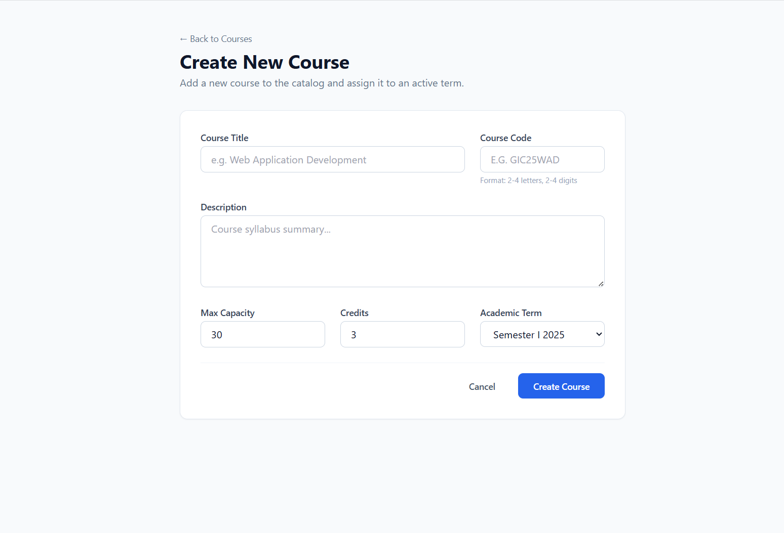

E4: Admin Dashboard

